Cheshire West and Chester
Public Spaces Protection Orders
Cheshire West and Chester Borough Council in exercise of the power under section 59 of the Anti-Social Behaviour Crime and Policing Act 214 (“the Act”)being satisfied that the conditions set out in section 59 of the Act have been met make the following Orders:
Subject to specific exemptions and defences, Persons within the area shown below shall:
- Not allow dogs to enter the following areas:
A Fully Enclosed Children’s Play Areas which contains Play Equipment
A Fully or Partially enclosed Multi Use Games Areas (MUGAs)
A Tennis Court
- If in charge of a dog, have with them the means to pick up dog faeces
- At the request of an authorised officer place the dog on a lead with a maximum length of 2m and keep it on that lead as directed to do so by the authorised officer. The 2m length can be a fixed, clipped or locked length
- Not walk more than 6 dogs at any one time, whether on behalf of a business or otherwise
- Not smoke within a Fully Enclosed Children’s Play Areas which contains Play Equipment
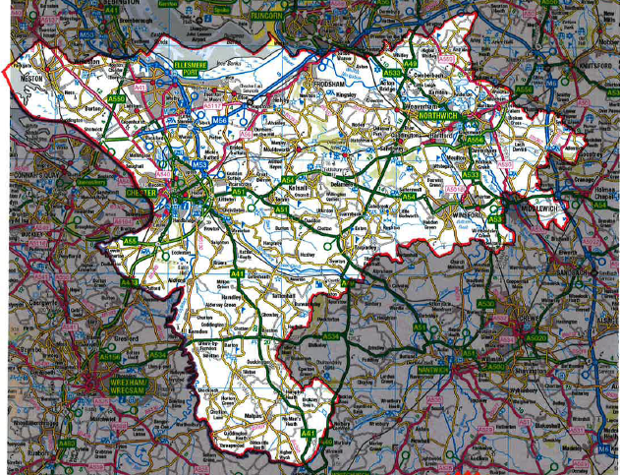
This Order will Commence on 20th October 2018 for a Period of 3 years. Any person who fails to compy with the requirements of the Order is guilty of an offence and liable on summary conviction to a fine not exceeding £1000 or a fixed penalty notice of a maximum £100.
Chester City Public Spaces Protection Order 2016 -2019
www.cheshirewestandchester.gov.uk

